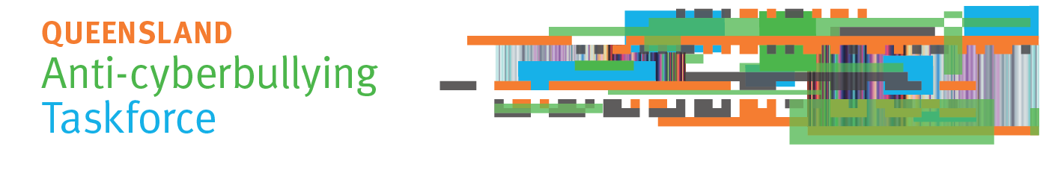
Communiqué – 1 May 2018
Public consultation is open
The Queensland Anti-Cyberbullying Taskforce has launched consultations to seek community views about how to prevent and respond to cyberbullying of young people up to the age of 25.
The Taskforce has invited submissions, and is holding public forums and roundtable consultation meetings across the community. In April the Taskforce held roundtable consultation meetings with representatives of the young refugee and migrant community, the LGBTI community, school guidance officers and school nurses, and youth organisations in Brisbane and regional locations. Consultations will continue until early June.
How to have your say
- Make a submission
Individuals and organisations are invited to send suggestions to prevent cyberbullying, and to support those affected if a young person is cyberbullied.
Send your submissions by email to antibullyingtaskforce@premiers.qld.gov.au, or via the Taskforce website at www.qld.gov.au/cyberbullyingtaskforce. Submissions close on Friday 1 June 2018.
The Taskforce will not publish submissions. De-identified examples of people’s experiences of cyberbullying may be used in a Taskforce report about its consultations. Organisations that make a submission are free to publish their own submission if they wish.
- Attend a public forum
Public forums are open to anyone interested in contributing their ideas to prevent and respond to cyberbullying of young people. Forums are scheduled in Brisbane, Caboolture, Cairns, Helensvale, Kawana Waters, Mt Isa, Maryborough, Roma, Thursday Island and Townsville. Dates and venues are listed on the Taskforce website at:
www.qld.gov.au/cyberbullyingtaskforce.
April Taskforce meeting
At its April meeting the Taskforce considered Commonwealth regulation of cyberbullying, and Commonwealth and State laws that can apply to cyberbullying. Future meetings will consider a range of issues relevant to the Taskforce terms of reference, available at:
www.qld.gov.au/cyberbullyingtaskforce.
Taskforce report to government
The Taskforce is to report to the Premier by 31 August 2018 on a proposed framework and recommendations to address cyberbullying of children and young people in Queensland.

Questions? Contact the Taskforce secretariat
Email: antibullyingtaskforce@premiers.qld.gov.au
Web: www.qld.gov.au/cyberbullyingtaskforce
Ph: (07) 3003 9469

