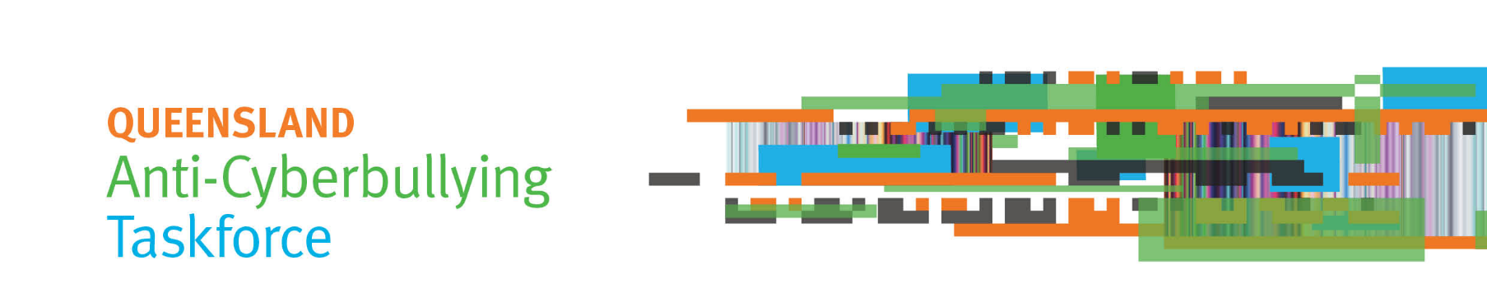

Communiqué – 20 June 2018

Public consultation
The Queensland Anti-Cyberbullying Taskforce has now finished its consultation meetings and forums. The Taskforce thanks all Queenslanders from across the State who shared their ideas on how to reduce and respond to cyberbullying of young people.
The Taskforce held more than 50 consultations as far north as the Torres Strait Islands, south to the Gold Coast, and west to Mount Isa. Consultations included:
- 13 public forums
- 9 roundtables with community organisations
- 9 roundtables with school staff ranging from principals and deputy principals to guidance officers and school nurses
- 11 young people’s forums
- 5 secondary students’ forums.
Consultation meetings were also held with representatives of stakeholder groups including:
- Aboriginal and Torres Strait Islander young people
- young people with a disability
- LGBTI young people
- young refugees, immigrants and asylum seekers
- medical professionals, psychologists, and social workers
- peak education bodies
- the Isolated Children’s Parents’ Association
- social media companies.
The Taskforce received more than 350 written submissions with suggestions to prevent cyberbullying, and to support those affected if a young person is cyberbullied. Submissions closed on 1 June 2018.
Late submissions may be accepted from organisations. Please contact the Taskforce Secretariat if your organisation would like to make a late submission.

Taskforce meetings
At its May meeting, the Taskforce discussed main themes from consultations to date and considered current Department of Education strategies and programs to prevent bullying and cyberbullying.

At its June meetings, the Taskforce considered current legislation relevant to cyberbullying, and how schools, parents and carers, and social media organisations may contribute to addressing cyberbullying of young people.

Taskforce report
The Taskforce is to report to the Premier by 31 August 2018 on a proposed framework and recommendations to address cyberbullying of children and young people in Queensland.

Questions? Contact the Taskforce Secretariat
Email: antibullyingtaskforce@premiers.qld.gov.au
Web: www.qld.gov.au/cyberbullyingtaskforce
Ph: (07) 3003 9469

