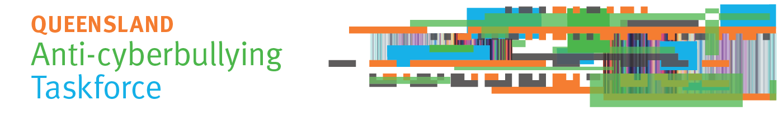Communiqué – 19 March 2018
First Taskforce meeting
The Queensland Anti-Cyberbullying Taskforce, chaired by Ms Madonna King, held its first meeting on 16 March 2018, the National Day of Action against Bullying and Violence.
Before the meeting, The Honourable Annastacia Palaszczuk MP, Premier and Minister for Trade, welcomed the Taskforce members and reaffirmed their important role to recommend action to prevent and address cyberbullying. The Honourable Grace Grace MP, Minister for Education and Minister for Industrial Relations, also welcomed Taskforce members.
Submissions invited
The Taskforce invites individuals and organisations to send the Taskforce their suggestions to prevent cyberbullying, and to support those affected if a young person is cyberbullied. Submissions about young people’s experience of cyberbullying are also welcome. Submissions can be made via the Taskforce website at www.qld.gov.au/cyberbullyingtaskforce. Submissions close on Friday 1 June 2018.
To ensure it receives as much relevant information as possible, the Taskforce does not intend to publish submissions. De-identified examples of people’s experiences of cyberbullying may be used in a Taskforce report about its consultations. Organisations that make a submission are free to publish their own submission if they wish.
Reducing and addressing cyberbullying
The Taskforce confirmed its focus on cyberbullying of children and young people up to the age of 25. The Taskforce will not consider or make recommendations about workplace bullying.
The Taskforce adopted a definition of bullying, adapted from that used on the Bullying. No Way! website:
Bullying is an ongoing misuse of power in relationships through usually repeated verbal, physical and/or social behaviour that is intended to cause physical and/or psychological harm. It can involve an individual or a group misusing their power over one or more people. Bullying can happen in person or using digital or other technologies, and it can be obvious (overt) or hidden (covert).
Bullying of any form or for any reason can have long-term effects on those involved, including bystanders.
Single incidents and conflict or fights between equals, whether in person or online, are not defined as bullying.
Consultation
Members discussed plans to consult across the Queensland community, including regional and rural areas. The Taskforce will consult with young people, parents, carers, families, schools, community organisations and experts. Details of consultations will be published on the Taskforce website in coming weeks.
Taskforce report to government
The Taskforce is required to report to government by 31 August 2018 and will propose a framework to address cyberbullying. The Taskforce will make recommendations for community and government action to reduce the incidence of cyberbullying. It will also advise government about activities under the framework, resources, best practices and other strategies to prevent and address cyberbullying behaviour.
Contact the Taskforce Secretariat
Email: antibullyingtaskforce@premiers.qld.gov.au
Web: https://www.qld.gov.au/cyberbullyingtaskforce
Ph: (07) 3003 9469

